http://www.thenewjournalism.org
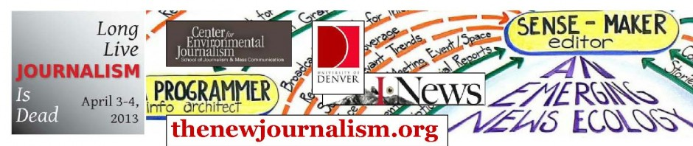
Students, journalists, librarians, videographers, community groups, media educators, technologists and engaged citizens
You’re invited!
If you believe in sustaining the values, principles and purpose of journalism in new forms and for new communities . . . that the old forms of storytelling – print and broadcast – are under challenge but their vital mission is not – then you need to join us in Denver, April 3 and 4.
Please decide now to participate in ‘Journalism is Dead, Long Live Journalism’ at the University of Denver. And learn below how your organization can be represented, too.

REGISTER NOW – RATES RISE MARCH 15
special discounts for students, groups
(SEE BOTTOM OF LINK: http://123signup.com/event?id=bfcbk )
You’ll be joining award-winning New Yorker journalist and writer Bill McKibben, NeW York Times columnist Sam Freedman and practitioners from The Associated Press, the Denver Post, the Reynolds Journalism Institute, the University of Colorado, the Poynter Institute and many others for:
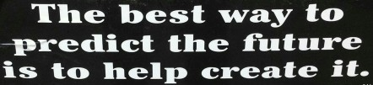
- A collective assessment of the current student and future opportunities for the Denver/Front Range media ecosystem.
On Wed., April 3, we’ll document what’s working and what’s possible. We need your help!
- A national idea-sharing and project-starting day of circle-round discussion and breakouts on Thurs., April 4. We’ll cover at least six themes: librarians and journalists, youth and media, ownership and communities, sustainability and revenue, climate-change reporting and newstools from the tech world.
This is going to be a great opportunity that brings together professional and mission-focused journalists, alternative media practitioners, journalism and media educators, librarians, technologists, not-for-profit news and public-relations people, and others interested in conveying messages for their communities.
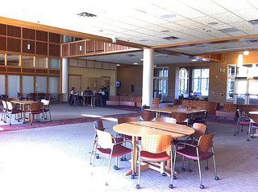
McKibben will be honored as the 2012-2013 Edward W. Estlow International Center for Journalism and New Media’s Anvil of Freedom Award winner, speaking and receiving his award at 6:30 p.m. on Wednesday, April 3.
The Colorado information scene has dramatically changed in recent years, as evidenced by the attention focused on the state during the recent presidential election and by a recent Poynter report. Some changes include:
- A large and growing Latino population and the concurrent rise of dual language media.
- Village Voice Media’s purchase of Westword and its relocation to the area.
- Demise of the beloved Rocky Mountain News.
- The “death” -- and rebirth -- of journalism at the University of Colorado.
Given the changing landscape, what’s possible now?
Your organization can be represented in The Commons
Journalism is Dead, Long Live Journalism will start with a showcase of media and civic outlets we’re calling the Front Range's News and Information Commons. The Commons will make visible the transformation underway in how we source and consume the news and information vital to our civic life. We would like you to show your wares and demonstrate what you’re already doing to change the nature of our news and information environment.

As a Commons participant, you will have a table open for about 2 hours from 11:00 a.m. to 1:00 p.m. on Wednesday, April 3 to show whatever you are doing and excited about.

Criteria for participating are:

1. Register for the entire event – April 3-4 at www.thenewjournalism.org. You'll find a question in the registration form to indicate that you wish to host a table. It asks you to enter a paragraph (~250 words) to describe your organization.

2. Create your own exhibit. We will supply the basics: outlets, tables, chairs.

3. Invite others to come and join us. Please forward this email to everyone you know who has something to say about the contours and direction of our media landscape and of our public life.

“Journalism is Dead; Long Live Journalism,” is the first visit to the Rockies by Journalism That Matters Inc., a decade-old, non-profit dedicated to educating and inspiring practitioners in the new news ecosystem, through regional and national events like this. We've got a great group of participants lined up for this event, as you'll see on our constantly updated site. Check out who’s already registered!

Please contact us at jtm@journalismthatmatters.org if you have questions or if you have an idea you would like to contribute to the event's planning. Register online now!

http://www.thenewjournalism.org
General questions? Call 617-448-6600.

Cordially,

. . . The JTM Team: Bill Densmore, Peggy Holman, Mike Fancher, Stephen Silha, and Michelle Ferrier, Jorge Reina Schement . . .

. . . plus a growing list of JTM-Denver co-convenors, including: Lynn Clark (Estlow Center), Kevin Dale (Denver Post), Laura Frank (Rocky Mountain PBS / iNewsNetwork), Paul Voakes and Tom Yulsman (Univ. of Colo.), Diane Alters (Colorado College), Cara DeGette (Metro State), Ted Anthony (AP), Randy Picht (Reynolds Journalism Institute), Kelly McBride (Poynter), Jan Schaefer (JLab), Josh Stearns (Free Press), and Kara Andrade (Ashoka Fellow)

