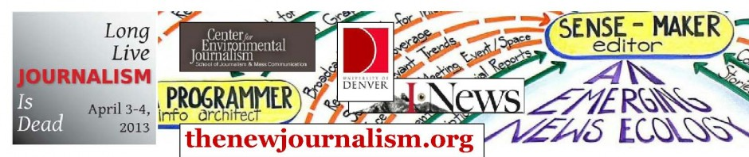


Come help map our Front Range news ecosystem

Wed./Thu. April 3-4: Register for a two-day workshop; help build the future of news and communities in the Rockies . . . at the Univ. of Denver’s Estlow Center

YOUTH, ENVIRONMENT . . . YOUR IDEAS!

http://journalismthatmatterhttp://journalismthatmatters.org/newjournalism/files/JDEADLLJ.d1-
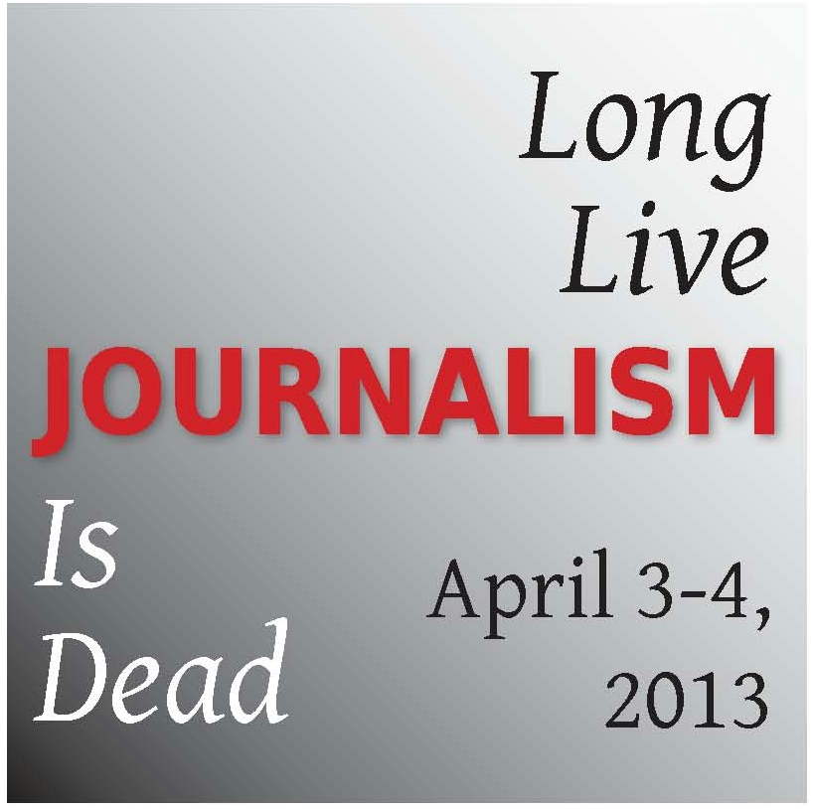

Featured speaker:
Bill McKibben, founder: 350.org, author, journalist for The New Yorker.

Wed., April 3, 6:30 p.m., Univ. of Denver

(talk is free and public)

http://www.thenewjournalism.org
Presented by Journalism That Matters / News values, principles, purposes, leadership
For journalists, technologists, educators, students, librarians, and engaged citizens

